CENWP-OP-B
14 June 2006
MEMORANDUM FOR THE RECORD

SUBJECT: Dead chinook at Bonneville’s Adult Fish Facility (AFF).

- CRITFC reported a sample mortality that occurred around 1300 on 14 June.
- A Project Biologist examined the fish and took photos (attached).
The chinook measured 81 cm, weighed 6.63 kg, and was not adipose clipped. It did not exhibit external injuries and appeared healthy. Water temperature measured 16.3 degrees Celsius.
- CRITFC reported that the chinook did not recover from clove oil after sampling.
- This is the first mortality for CRITFC this season.

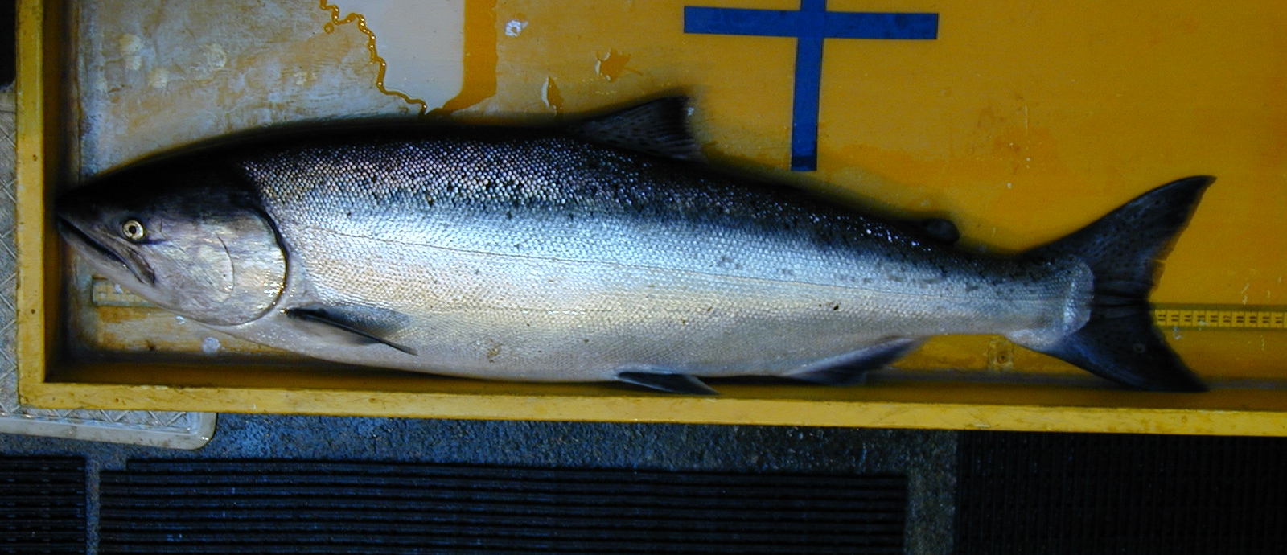

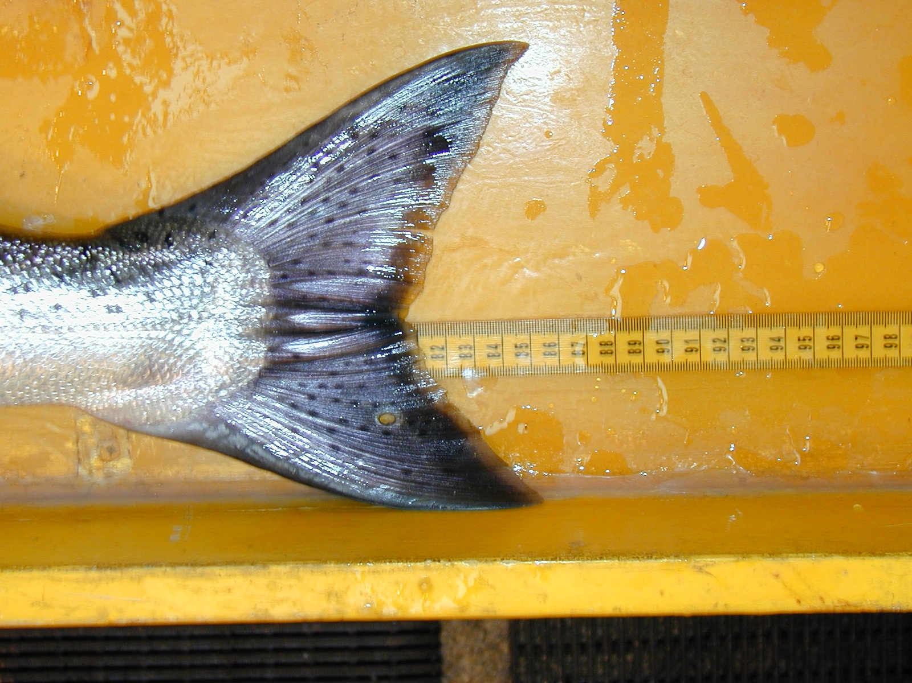

Jon Rerecich
Bonneville Fisheries Biologist

